# Introduction to Programming – Exercise

The goal of this exercise is to practice **creating projects for your homework/exams**. Your task is to create a solution containing C# projects.

## Create A Blank Solution

Open Visual Studio and select **File -> New -> Project**. Then from the menu to the left choose **Installed-> Templates -> Other Project Types -> Visual Studio Solutions -> Blank Solution**. Choose an appropriate name and click **OK**.

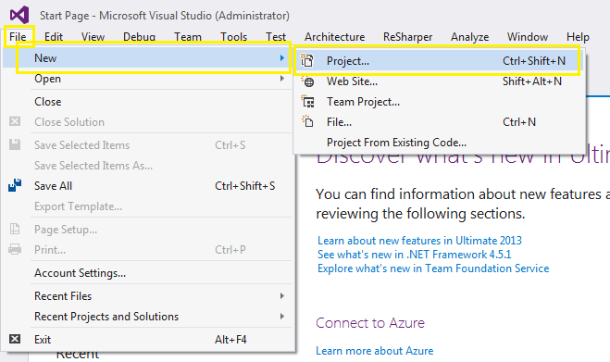

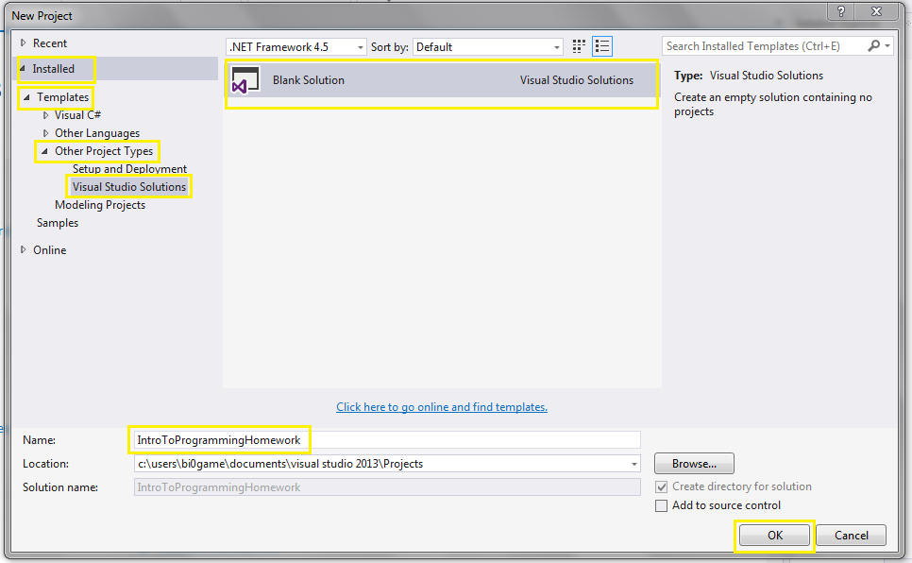

## Adding Projects To Solution

From the top menu select **File -> Add -> New Project**. Then from the menu to the left choose **Installed -> Visual C#** and then select from the middle menu select **Console Application**, **name** **it appropriately** and click **OK**.

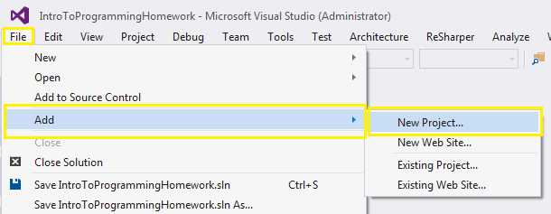

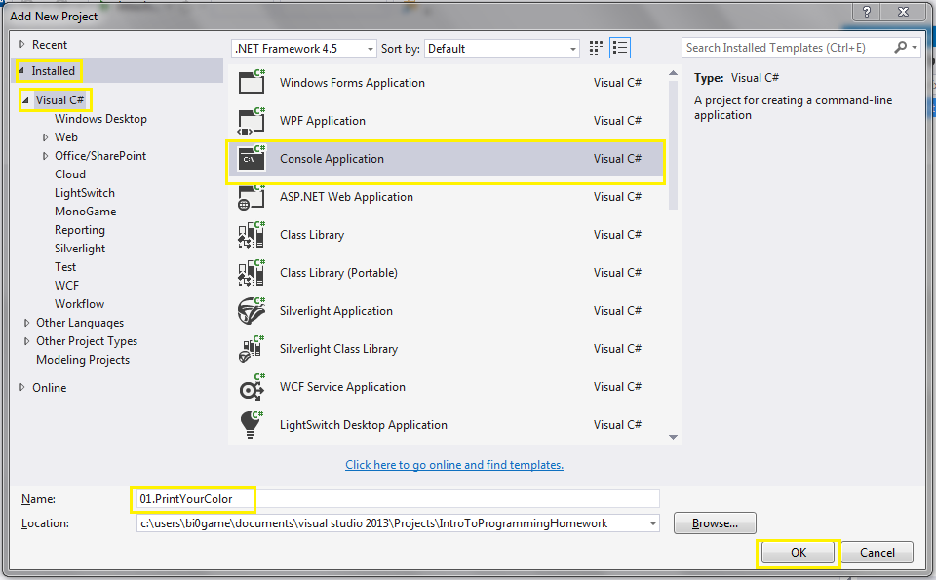

## Fix The Auto-Generated Code

After you have added your new project to the solution, you need to **fix** **some** of the automatically generated **code** done by Visual Studio. First you need to **remove** some of the **libraries** that you **do not need**. Then you need to **remove** the **namespace** as you do not need it as well. Next thing is to **rename** the **class** so that it has a **descriptive name** (as shown in the picture) and **remove** the "**string[] args**" in the **parentheses**. Finally you need to **rename** the **.cs file** in the project to **match** the **class' name**.

|  |  |
| --- | --- |
| **C:\Users\Bi0GaMe\Pictures\5.PNG** | **C:\Users\Bi0GaMe\Pictures\5.2.PNG** |
| **C:\Users\Bi0GaMe\Pictures\6.PNG** | **C:\Users\Bi0GaMe\Pictures\6.2.PNG** |

## Write Some Code

You need to write some code that prints out your favorite color.

1. Between the {} parentheses of the Main method you need to write the Console.WriteLine(); method.
2. Now you need to write your favorite color in double-quotes and put it in the WriteLine method.
3. Finally you need to press Ctrl + F5 to build and run your program

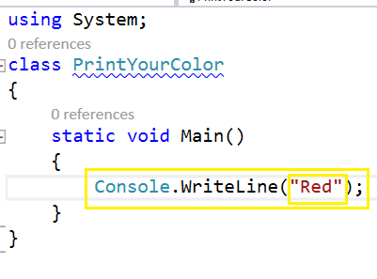

# Submitting a solution as a homework

The goal of this exercise is to show you how to submit a solution as homework.

## Finding Your Solution

From the **Solution Explorer**, **right click** the **solution** and select **Open Folder in File Explorer**.

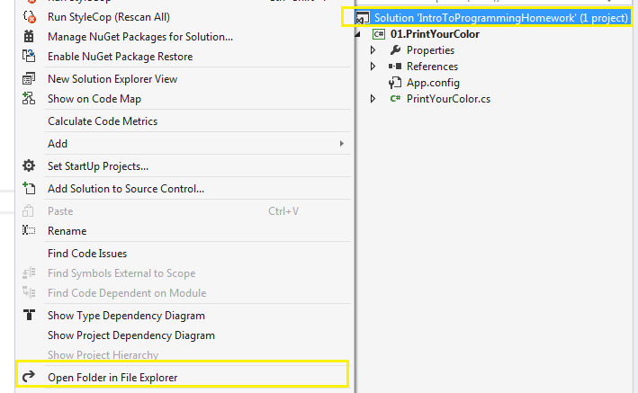

## Creating An Archive

You need to **create** an **archive** from the **project folder**. To do that you need an **archiving software** and **select** the **folder** you want to archive.

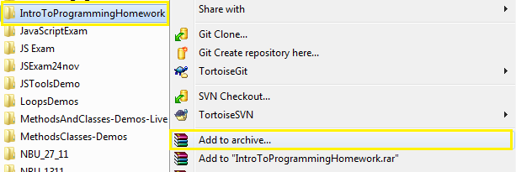

## Submitting The Archive

You need to submit your **archive** you created as homework in the SULS system.

